**Report TP1**

**Subject:** Postgresql

**Students:** BOURBAI Ismail.

**Source Code:** [GitHub Repository](https://github.com/IsmailBourbie/master-one-practical-work/tree/master/dbms_administration/TP1/Ismail_Bourbie)

**Q1.1:**

The following screenshots show the queries of creation some tables:

* PS: All the queries are available in the source code (GitHub or the SQL attachment file).

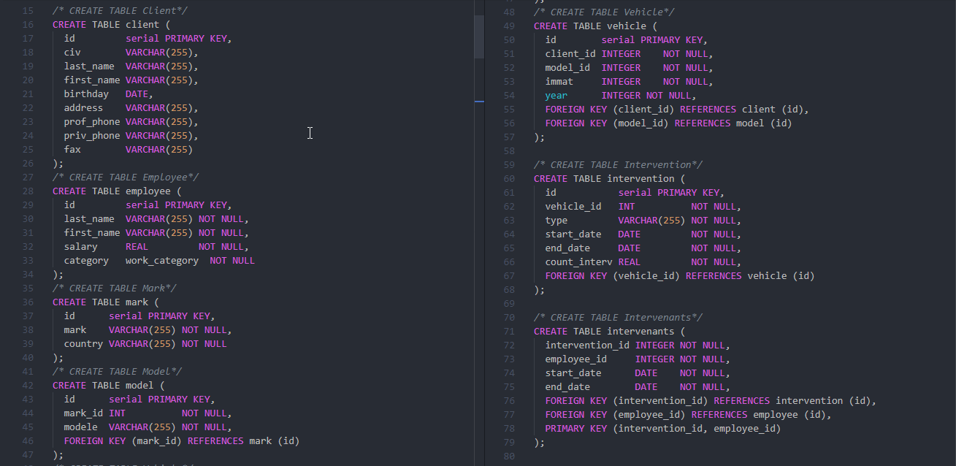

Figure 1 Creations of tables

**Q1.2:**

There is a lot of problems encountered:

* The field value of birthday date of the last row in client table (M. Lamine MZEABAT) is out of the range: “09/13/1965”.
* The *NUMMARQUE = 45* is not found in table *mark,* and when try to insert it in *model* table it’s violates foreign key constraint.
* The same previous problem:
* *NUMMODEL = 77* is not found in table *Model* when inserting on *Vehicle* table.
* *NUMCLIENT = 80* is not found in table *CLIENT* when inserting on *Vehicle* table.
* *NUMMODEL = 77* is not found in table *Model* when inserting on *intervention* table.
* *NUMEMPLOYEE = 88* is not found in table *Employee* when inserting on *intervenants* table.